**Problem 01**

Write a program that will accept an integer and execute one of the following based on the input using IF statements:

1. If 0, display only “Hello World”.
2. If 1, display only “I am Groot”.
3. If 2, display only “To the Top”.
4. If 3, display only “Where is the horizon”.
5. If 4, display only “I do not know”.
6. If none of the above, display only “Yeah, I will”.

**Solution and Testing 01**

For this solution, to ensure that only integers will be accepted, we shall have to validate if the input is numeric. I put this validation on the top of the IF-block. We shall assume that the output is “Yeah, I will”, if the user makes an invalid input. The rest of the conditionals are simple IF-ELSE statements.

Below is the screenshot of solution program as well as testing in the terminal.

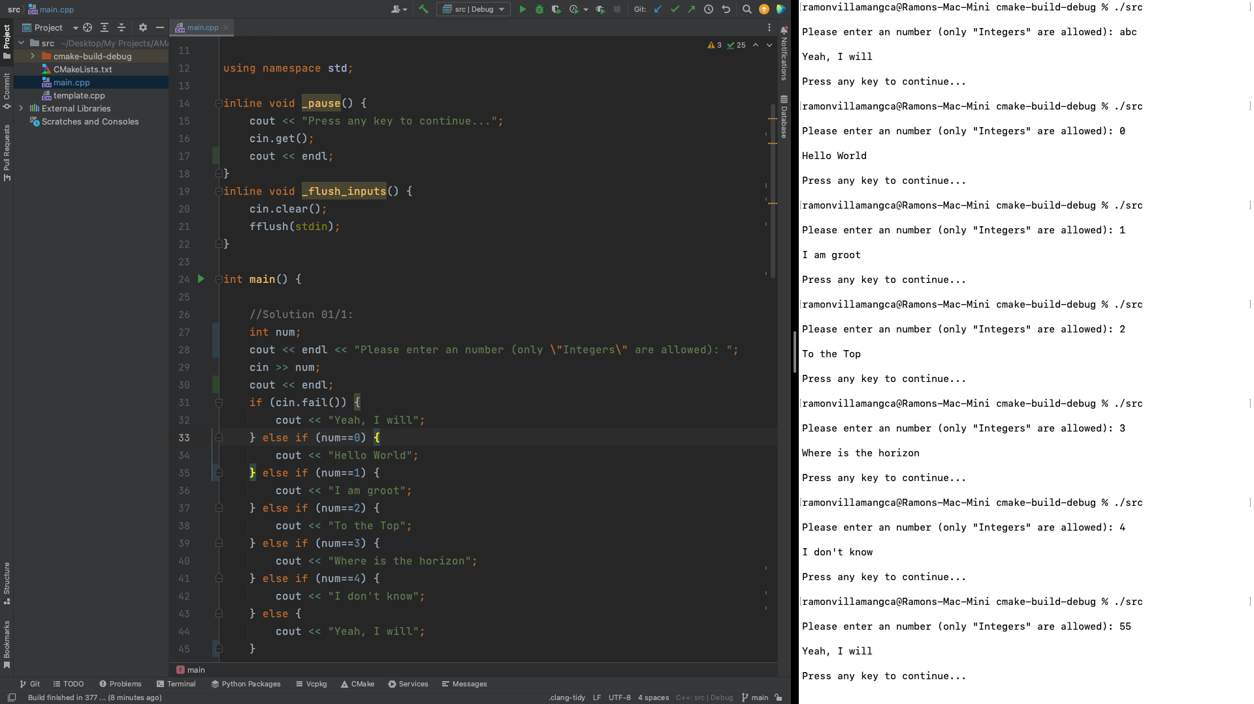

Since the IF-ELSE statements we are dealing are just one-liner codes, we can still simplify our code by removing all curly braces. We also merged data validation and the check if the number is greater than four, in one IF statement.

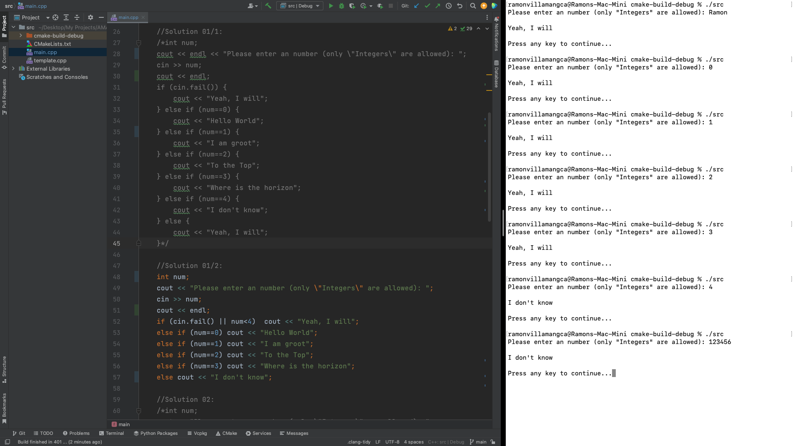

**Problem 02**

Write a program that will accept an integer and execute one of the following based on the input using SWITCH statements:

1. If 0, display only “Hello World”.
2. If 1, display only “I am Groot”.
3. If 2, display only “To the Top”.
4. If 3, display only “Where is the horizon”.
5. If 4, display only “I do not know”.
6. If none of the above, display only “Yeah, I will.”.

**Solution and Testing 02**

In this problem we just use the SWITCH-block without further simplification. We still need one IF-statement for the data validation, though.

Below is the screenshot of solution program as well as testing in the terminal.

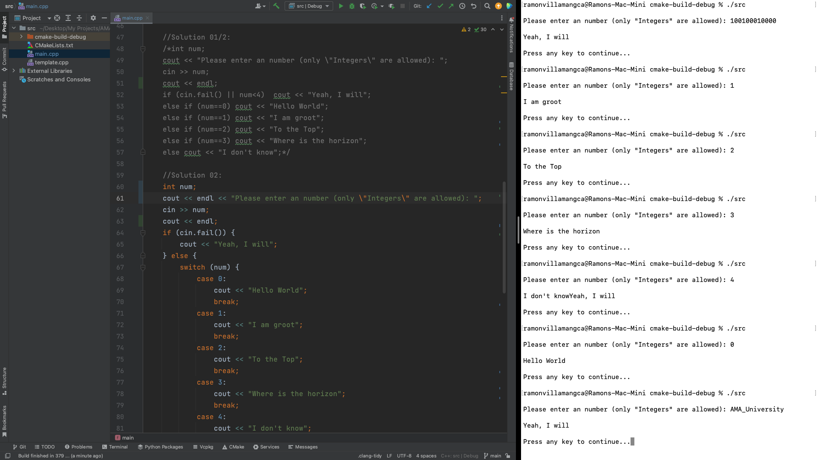

**Problem 03**

Write a program that will divide the two floating points entered by the user (first number entered divided by the second number entered). Make sure your application handles all possible scenarios with floating points.

**Solution and Testing 03**

We can see three (4) possible scenarios here:

* The user inputs an invalid data, i.e. non-numeric.
* The user inputs zero (0) as the second number. This is unacceptable because division by zero is undefined in mathematics and programming.
* The user inputs an integer instead of a float. We shall consider this as valid, since the compiler will automatically “cast” any numeric value to the correct type of the variable to be assigned.
* The user inputs a valid float value.

We shall use the same data validation scheme we used in the previous problem. However, here we keep asking the user for another input until he/she provides a valid input.

Below is the screenshot of solution program as well as testing in the terminal.

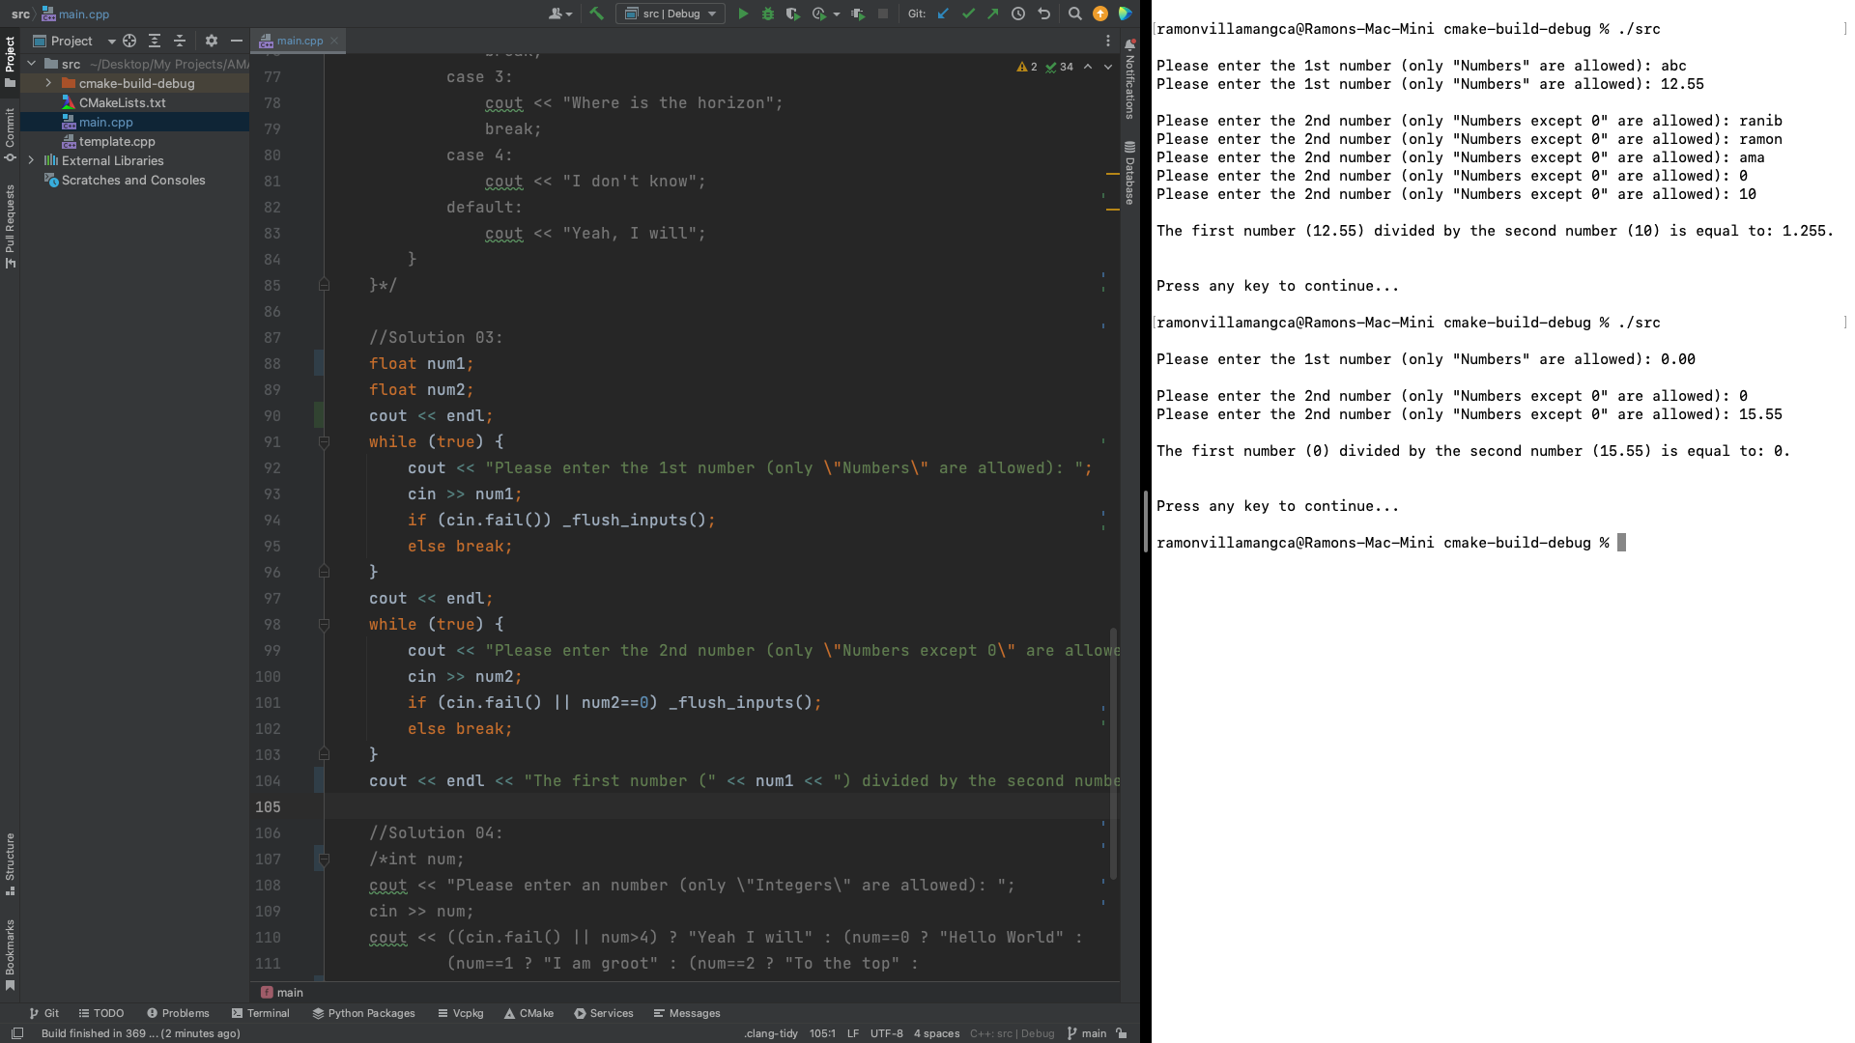

**Problem 04**

What can you conclude from this activity?

**Answer 04**

Below are not only my conclusions but also my observations as well.

1. We can still simplify the solution to problem 1, by using “ternary operator”. This will greatly simplify and reduce are code. Ternary operator is a 3rd type of conditional that was not taught in this chapter. As we always say, “Think outside the box”. Below is the implementation:

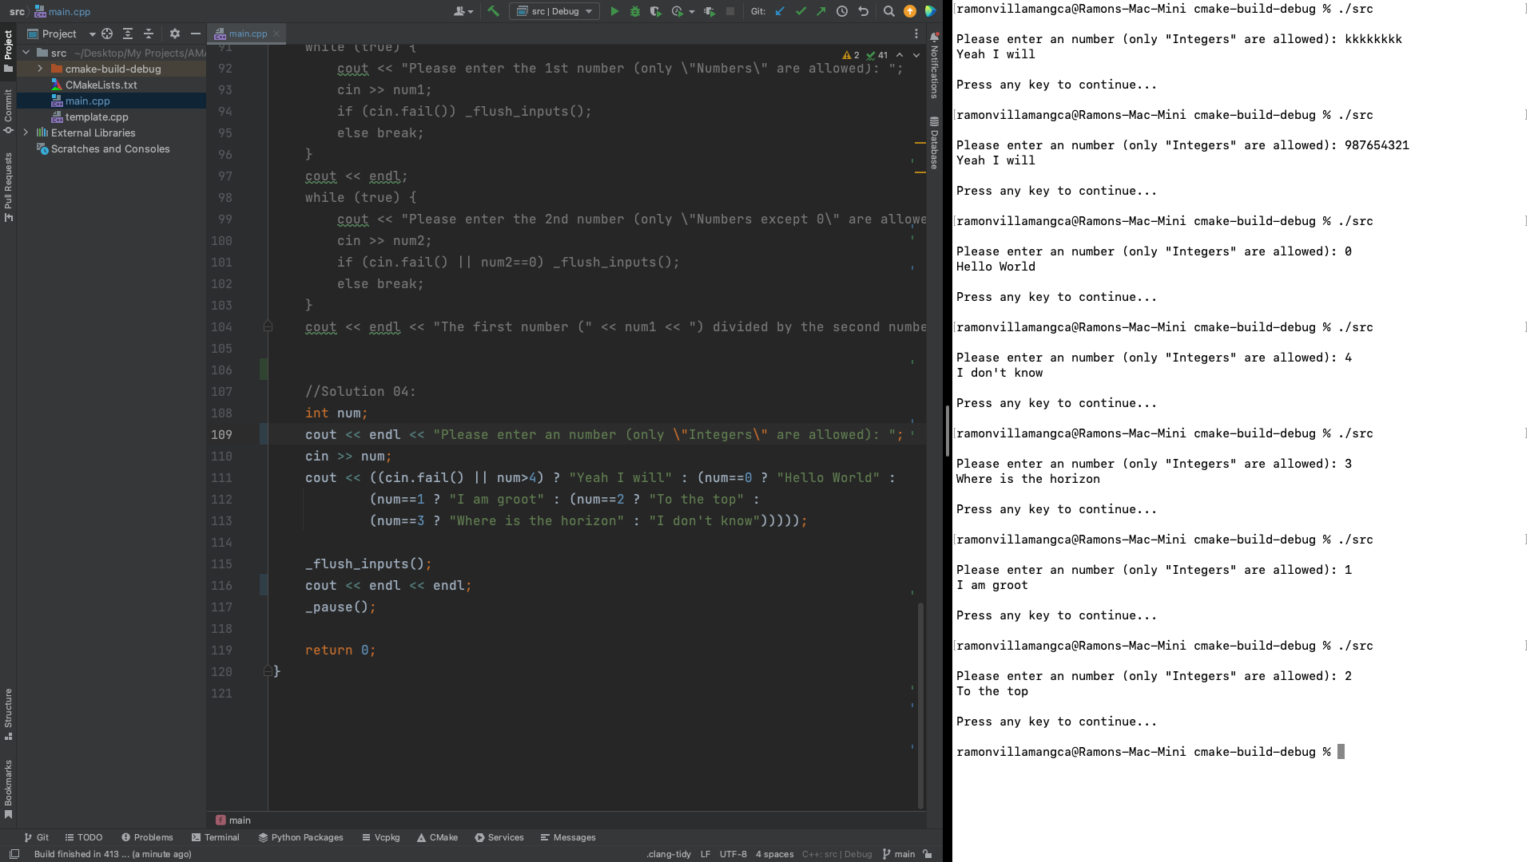

1. The data validation I used in this chapter is simply checking if cin fails. cin will fail if the input data is not of the same type as the declared variable to which the input is to be assigned. This solution is far from perfect though, because cin will accept as numeric any input that starts with numeric characters, discarding trailing non-numeric characters. A better solution would be to accept the input as string, check each character, if it only contains numbers and decimal point, and then if all numeric cast it to float and assign it to another numeric variable. That method is far more complex for this exercise. In fact, data validation is beyond what we suppose to know from what is taught so far. But that what is required by the problems so again “think outside the box”.
2. Again, the solutions I presented is just one of the many possible ways to attack the problems above.

------------------------

**NOTE FOR THIS PROBLEM:**

Source code can be found on my GitHub page: <https://github.com/rvillamangca/>.

